Our topic this half term is all about how the layers of the rainforests. Here are some ideas for activities you can do to enrich the work we do in school.
There are 4 ideas here including one big challenge – can you do two or more over the half term?
ART
Can you find any interesting rainforest or jungle art that you could attempt in a similar style?
(MAYBE A COLLAGE?)
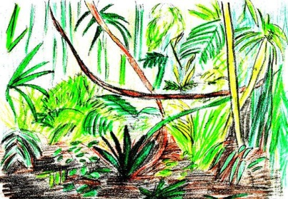

Make up a RAINFOREST information poster or FactFile full of whatever information and images you can gather
MAIN CHALLENGE
D&T / MAKE – diorama
Can you create a ‘rainforest in a box’
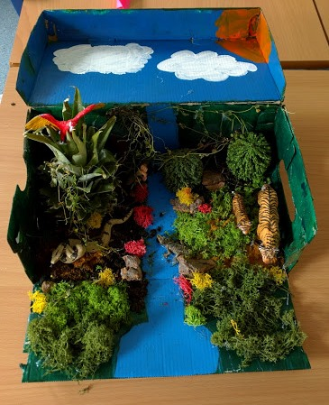

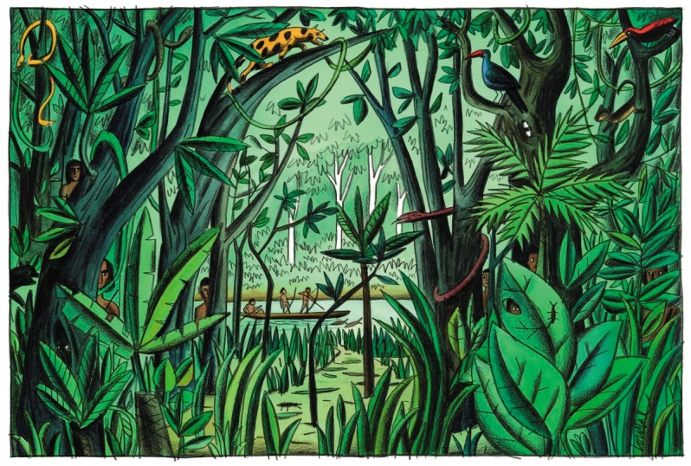

Choose a rainforest animal – what would it be like to live in a rainforest?
Write a day in the life of your animal or a description of the animal or even a poem about the rainforest or your animal.

