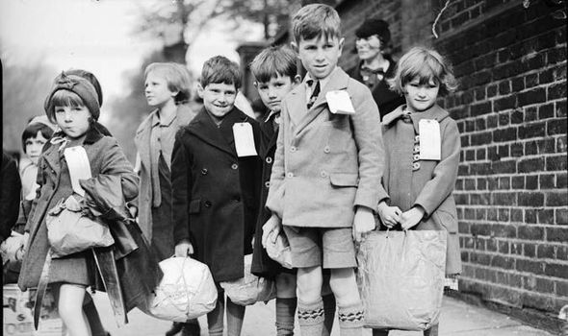

Further Research:

Find out about The Blitz. Which part of the country did it affect? Write a news article.

Can you research what happened locally during WW2? Were any of your family members involved?

TASK 7

TASK 7

Rationing affected most people in Europe. Research: ration cards, recipes and what was available to buy in the shops. You could write a short play about shopping during the war. You can download ration and identity cards. Why not try out a recipe?

TASK 4

Each night, The Black Out affected families and children. Find out about the strict regulations and design a poster to inform the public.

TASK 6

**Topic Enrichment/ Home Learning**

Y6, our last history topic this year is: How WW2 affected children in Britain? Here are some topic challenges for you to try at home. First you need to find out when and why the war started. There are lots of useful websites and films to help you with your research which I have listed.

What was Operation Pied Piper? Make a fact sheet with images about this important event.

TASK 1

Air raid shelters played an important part in the lives of families in WW2. Research the different types and then make a model of an Anderson Shelter.

TASK 5

Make a war time diary/book about an evacuee. Include images of your family or gather images of an imaginary family using internet photos. Include letters from your Dad in the armed forces. Make it look like a suitcase with lift the flaps for secret thoughts.

TASK 2

Paint or draw a picture of yourself as an evacuee. Maybe you could dress up and take a photograph. You will need to research fashion of the 1940’s

TASK 3