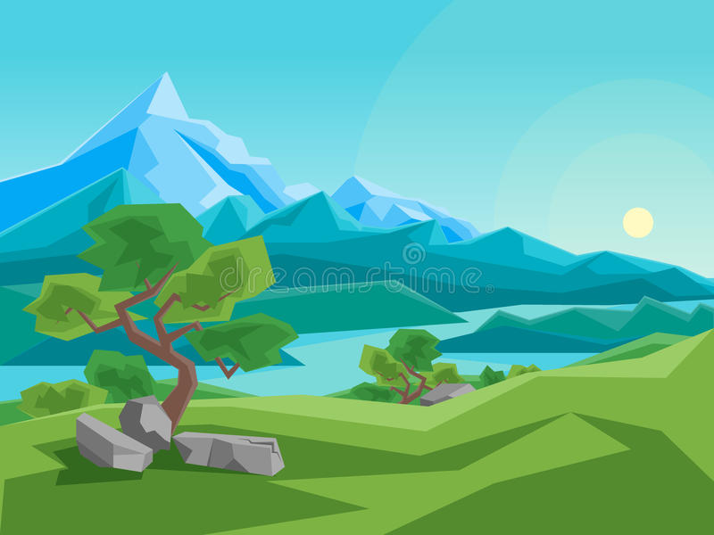

Look at photographs of mountains for inspiration and paint a landscape. Alternatively, the closest thing we have to a mountain in Bury is Holcombe Hill. Climb it with your family and take photographs which could then be your inspiration for a painting.

TASK 7

TASK 7

If you were to go on holiday to a mountainous region, which range would you choose and why? This task involves researching where the ranges are, what the ranges are famous for, their climate, how much it might cost to travel there and what equipment you might need. Prepare a PowerPoint or some other means to persuade your parents to travel.

TASK 4

**Topic Enrichment/ Home Learning**

“Is it a hill or is it a Mountain?” This is the last topic we will investigate in Y6. Here are some topic challenges for you to try at home. There are lots of useful websites and films to help you with your research which I have listed.

Find out about Sherpa Tensing and Edmund Hillary. Why are they famous? Write a fact file for each.

TASK 3

Find out how mountains are formed and draw diagrams to explain the different types.

TASK 6

Locate the world’s mountain ranges and find out if the UK has any mountains.

What are the highest peaks in the mountain ranges?

When does a hill become a mountain?

TASK 1

TASK 1

Make a model of a volcano and make it erupt. You will have to research how to do this and ask permission before you begin!

Where are the active volcanoes in The World?

TASK 5

Find out about Mount Vesuvius and the ancient City of Pompeii and make a leaflet for tourists advertising the amazing sights.

TASK 2