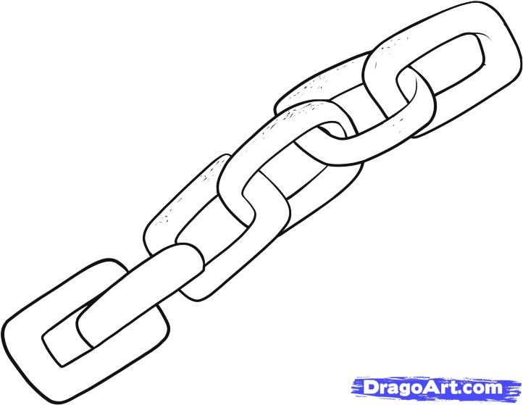

Many of the slaves worked on cotton and sugar plantations. Find out how these plants grow and make an information sheet which combines information and images.

TASK 4

bines information and images.

TASK 4

Write a poem about slavery in whatever style you choose except Acrostic.

TASK 7

Olaudah was born in an area now called Nigeria. Find out what Nigeria is like today.

TASK 3

Write a diary extract in role as Olaudah Equiano or his sister after being kidnapped and kept a prisoner on the slave ship

TASK 1

Find out about William Wilberforce and why he was so important.

TASK 2

The African slaves made patchwork quilts. Make a small patchwork sampler.

TASK 6

Write play script about a slave auction in South America.

TASK 5

Topic Enrichment

As well as your maths and literacy homework, here are some topic challenges for you to try at home. You can do them in any order but try to do at least one per fortnight. Hand in your work then we can share your ideas with the class.

**Slavery**