Our topic this half term is all about life in the Indus Valley – an ancient
civilisation from about 4,500 years ago.
Make up an Indus Valley scrapbook or poster full of whatever you can find out
ART – can you create a piece if Indus artwork – it could even be using the words INDUS VALLEY or INDUS CIVILISATION
Create a simple INDUS acrostic

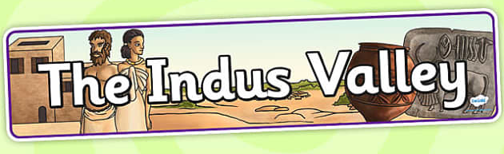
MAKE – a basic Indus style board game with simple rules
ICT – research and find out – what was life like for people who lived in the Indus Valley 4,500 years ago?

