Worry Dolls

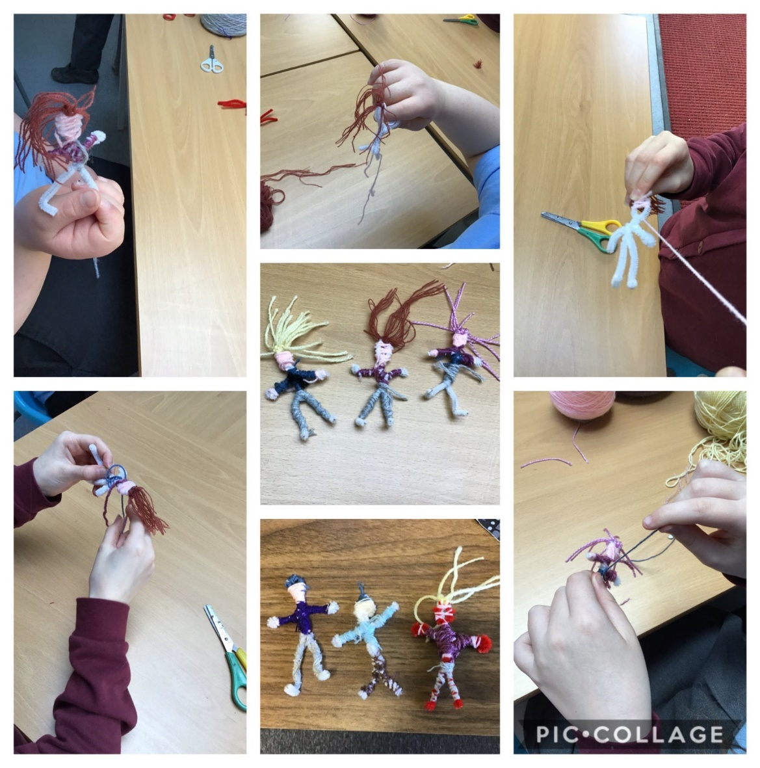
To make worry dolls you will need:
- Pipe cleaners
- Different colours of wool
- Scissors
- Glue
Here are the instructions how to make your worry doll:
- You will need to bend your pipe cleaner into the shape of the doll. First, you fold your pipe cleaner in half then make a loop at the top of the pipe cleaner and twist (this will be the head). 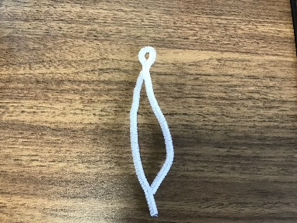
- Next take one of the long pieces and fold that, making sure you go behind the body (this will be the arm) 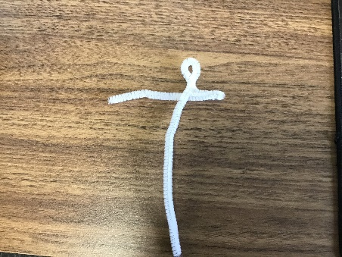
- Fold the other part of the arm diagonally across the body (this will be the leg).
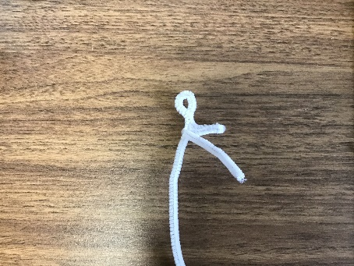
- Repeat the other side by folding the other long part of the pipe cleaner to create the arm but this time instead of going over the shoulder, twist it around the top of the other leg to create the tummy.
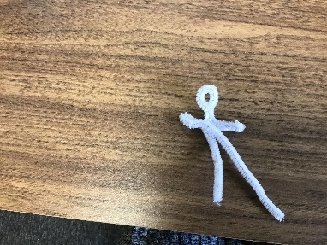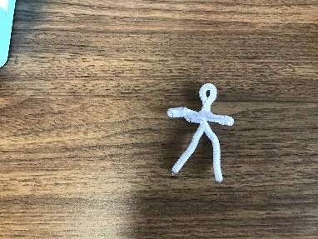
- Get some coloured wool for your hair. Cut it to size and tie it around the loop (the head).
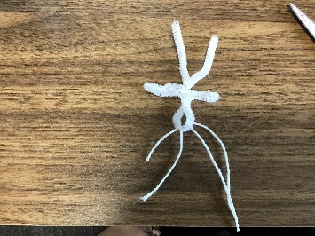
- Get some different coloured wool for the face, tie it in the side of the loop then wrap it around the loop to create the head, making sure you keep the hair out of the way. Cut the wool when you have finished and glue it in place so that it doesn’t unravel.
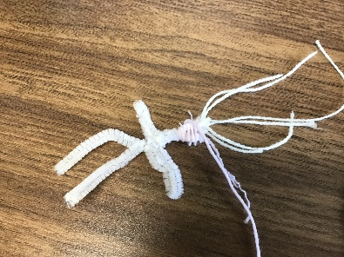
- Next get some different coloured wool for the top. Start at one of the arms, going over the neck to the other arm and back again then down and around the tummy. Again glue it in place so it doesn’t unravel.
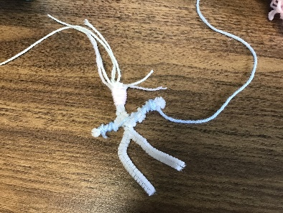
- After that, get some more different coloured wool to do the skirt or trousers. If you are creating a skirt, wrap the coloured wool half way around the legs (wrapping the legs together) in an upward motion to the tummy. If you want to create trousers, start at the foot and go up one side of the leg, around the tummy and down the other side of the leg. If you want to create a dress, start at one of the arms, going across to the other arm `and back again to go down the tummy (like the top) but carry on down to the knees. Glue the wool in place.
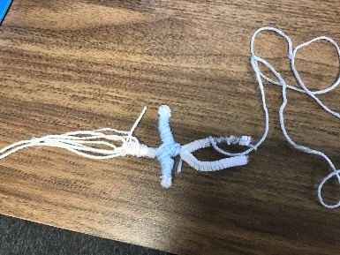

And there you have a worry doll! You can choose different colours of wool as well as different coloured pipe cleaners and make your own designs. Have fun and enjoy creating

