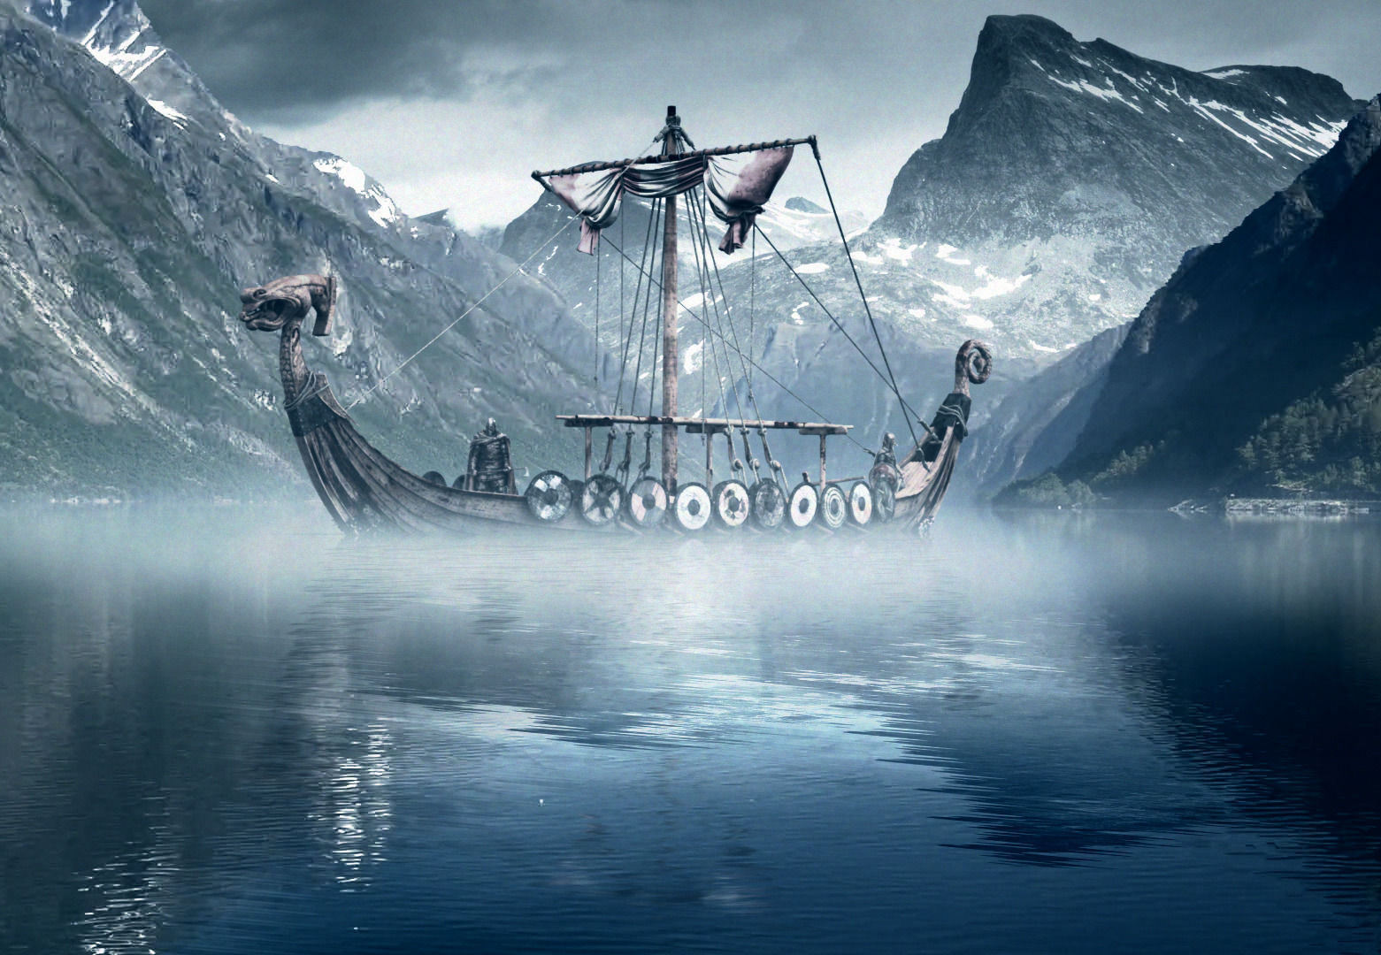

Find out what the Vikings wore and how their clothes were made.

TASK 5

As well as the work we are doing in class on our topic, here are some challenges for you to try at home. You can do them in any order, but try to do at least one per week.

**The Vikings**

Make a model of a Viking long boat.

TASK 1

Find out about Jorvik and why it was important.

TASK 4

TASK 2

Write a story in the style of a Viking Saga.

Create a model of a Viking shield or sword based on archaeological finds.

TASK 6

Research Viking gods and create fact file with images.

TASK 3