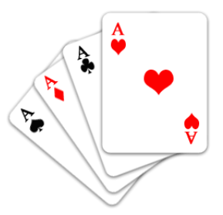There are some fantastic websites [](http://www.casinodicegaming.com/images/dice_home.jpg)

that we recommend that you have a look at.

Many of these will be familiar

to your child as we use some of them in school.

*Please always check a new website before*

*allowing your child to use it and monitor carefully the sites that they have visited.*

[www.ngfl-cymru.org.uk](http://www.ngfl-cymru.org.uk)

[www.crickweb.co.uk](http://www.crickweb.co.uk)

[www.ictgames.com](http://www.ictgames.com)

[www.bbc.co.uk/education](http://www.bbc.co.uk/education)

[www.channel4learning.com/sites/puzzlemaths/](http://www.channel4learning.com/sites/puzzlemaths/)

[www.counton.org](http://www.counton.org)

[www.mathsphere.co.uk](http://www.mathsphere.co.uk)(and click on free resources)

[www.woodlands-junior.kent.sch.uk](http://www.woodlands-junior.kent.sch.uk) (click on Maths Zone)

[www.beam.co.uk](http://www.beam.co.uk) (click on Maths of the Month)

[www.mathplayground.com](http://www.mathplayground.com)