Dear Parent /Carer,

At Old Hall, we understand the importance of reading and how there are endless benefits to children who read regularly. Academic research has shown consistently that reading for pleasure improves not only academic attainment but also mental health and economic success later in life.

Therefore, for the children who will be attending school, we have decided to continue with our reading scheme. This means that the children attending school will have daily guided lessons with their teacher. The children will also have the opportunity to read aloud to an adult each day. This will allow children to continue to develop their ability to read and develop their understanding of what they have read.

For the children who are attending school, please can we ask that you bring your reading book, which you took home at the end of the last term back into school with you. Unfortunately, due to the current situation we find ourselves in, children will not be bringing a reading book home at the end of each day. Their book will remain in school in their tray and once completed, the book will be placed into quarantine for 72 hours before being returned back to the shelf.

Sadly, during these current times, we are going to have children who are working remotely from home. This is a real shame as we were so excited to see you back at school; however, it is really important we do the best we can to keep everyone safe.
With this in mind, I thought I would include some free reading materials which you can access from home. These reading materials can also be accessed by children who are attending school to complete home reading.

Please can I ask that children who are working remotely from home keep their remote learning reading diary up to date. This will then allow your class teacher to have access to which books you have read, provide recommnedations and assess your progress. This doucment can be found on our school website.

All information regarding home learning can be found on our school website: https://www.oldhallps.com/

Yours Sincerely,
Mr Sharman
Assistant Headteacher

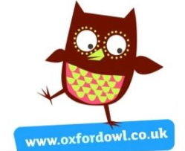
Free eBooks developed for children between 3 – 11 years old
Oxford Owl is a free resource that allows you access to
a variety of eBooks: https://www.oxfordowl.co.uk/for-home/find-a-book/library-page/

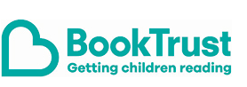
Story books, games and evening reading with signing
The Book Trust is committed to encouraging children to read
as well as improving their reading. Their website has lots of
books available, as well as games and Youtube links to adults
reading aloud: https://www.booktrust.org.uk/

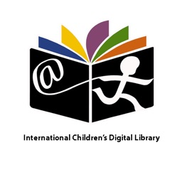
International Children’s Digital Library
International Children’s Digital Library ICDL is a non-profit organization that provides access to the best children’s books of their culture, and cultures around the world regardless of where they live. There are over 4,000 titles in 59 languages to choose from. If you want a personal bookshelf for your family, create a free account and save your favourite kids’ books, set personal preferences, and bookmark books you would like to read later: http://en.childrenslibrary.org/

Please see the information below to learn how to support readers at home.
