Useful websites for WW2
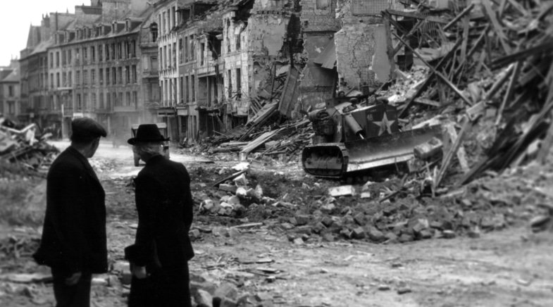
Y6, here are a few things to help you with your research. There are many others.
https://www.bbc.co.uk/teach/class-clips-video/history-ks2-world-war-two/zjnyscw- a comprehensive overview of WW2
https://www.bbc.co.uk/teach/school-radio/history-ks2-world-war-2-clips-the-declaration-of-war/z4qn6v4- Declaration of war.
https://www.bbc.co.uk/teach/school-radio/history-ks2-world-war-2-clips-index/zjc8cqt- BBC archive . Topics include The Blitz, rationing and songs.
https://www.youtube.com/watch?v=4idj7fI6OZg- Living through air raids
https://www.youtube.com/watch?v=0SYDBJAwYCI- an evacuees story.
http://www.primaryhomeworkhelp.co.uk/war/websites.htm- lots of facts and information.
https://www.youtube.com/watch?v=NPs2IXlDxRk- opening scene from Lion Witch and the Wardrobe- bombing and air raid shelters.
https://www.youtube.com/watch?v=C0KBaiiykas&list=RDPzOBF8fch3o&index=2- train station and leaving London
https://www.youtube.com/watch?v=PzOBF8fch3o- evacuation by train.
https://www.youtube.com/watch?v=kRt5Mk6V8Gg- full CBBC episode about evacuation. There are more episodes.
https://www.youtube.com/watch?v=LdMsoKrzvFY evacuation scene from Carrie’s war.
https://www.amazon.co.uk/Secret-War-Diary-Flossie-Albright/dp/1406331996- This is an example of a diary similar to one I would like you to make.
If you have finished all your tasks listen to some 1940’s music. How does it differ to music we listen to now?

